**Power BI Assignment : 2**

**Name : Nooras Fatima Ansari**

* **Connect to the Store Sales Data and do the following:**
* **Remove all the blank rows.**
* **Update the column header if they are not updated**

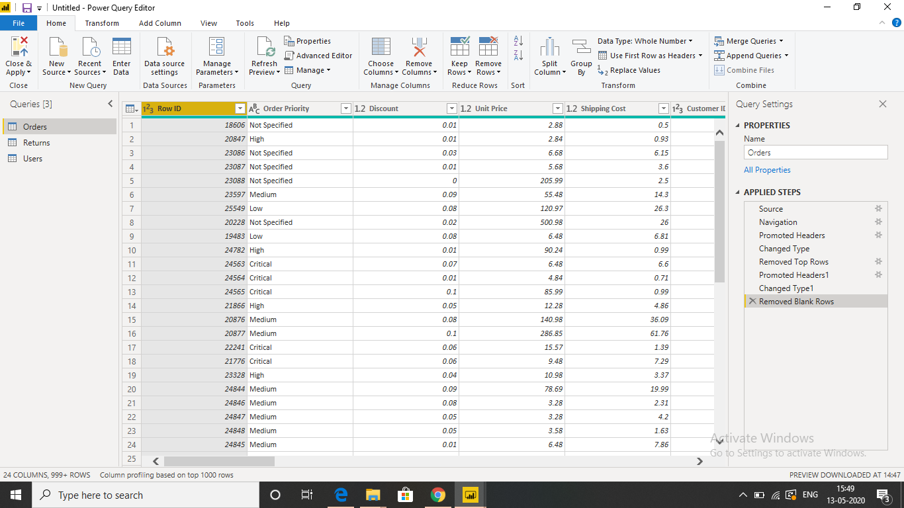

* **Create a text table and show the sales in terms of**
* **Customers**
* **Product Category**
* **Regions**

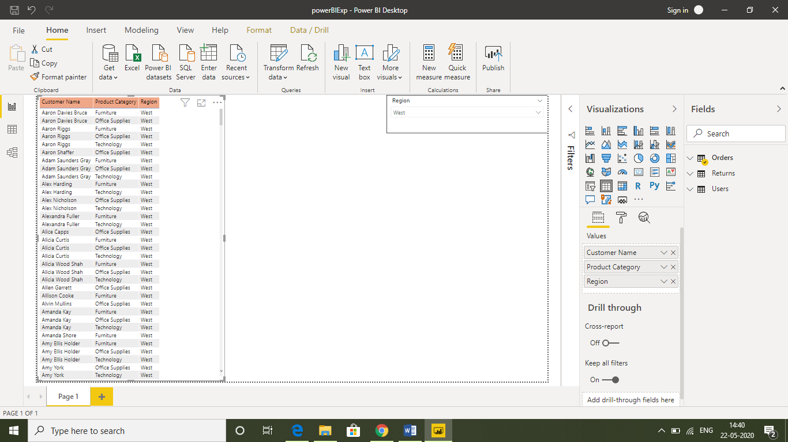

* **Create a line and Clustered Column Chart showing the Sales and Discount as per the State or Province**
* **Format the bars and line with different colors**

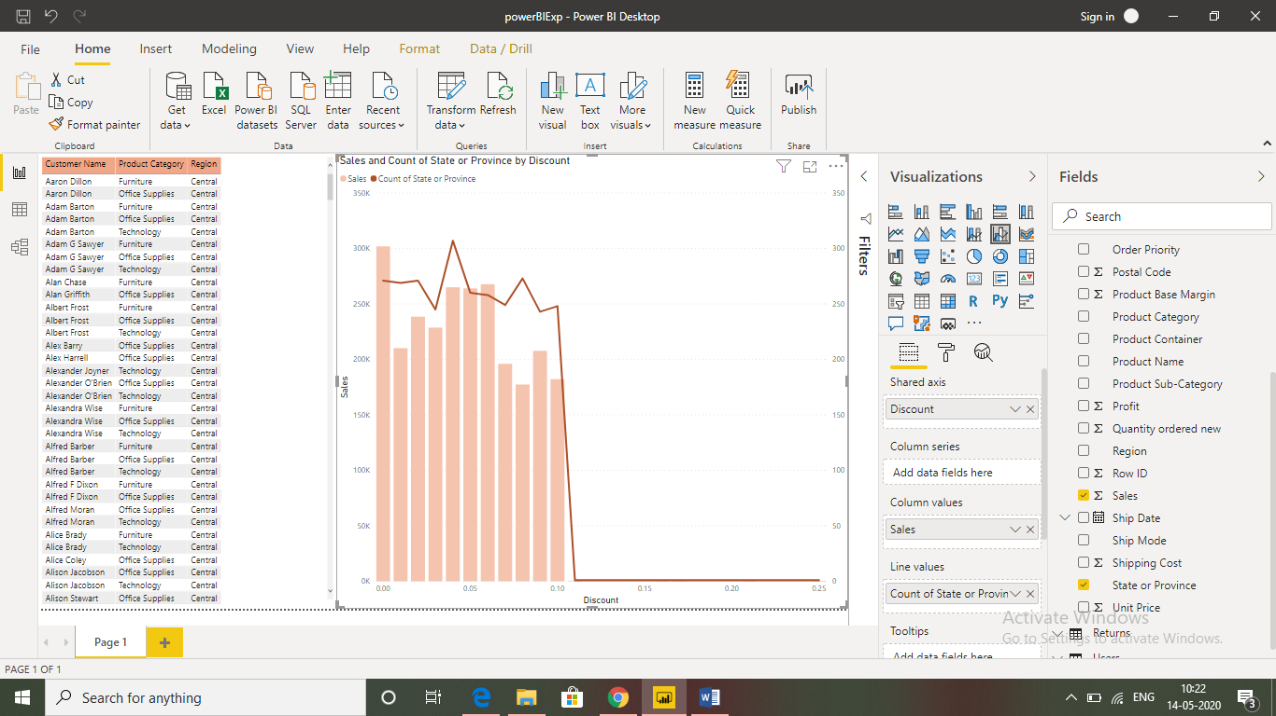

* **Which state has the highest sales in terms Technology**

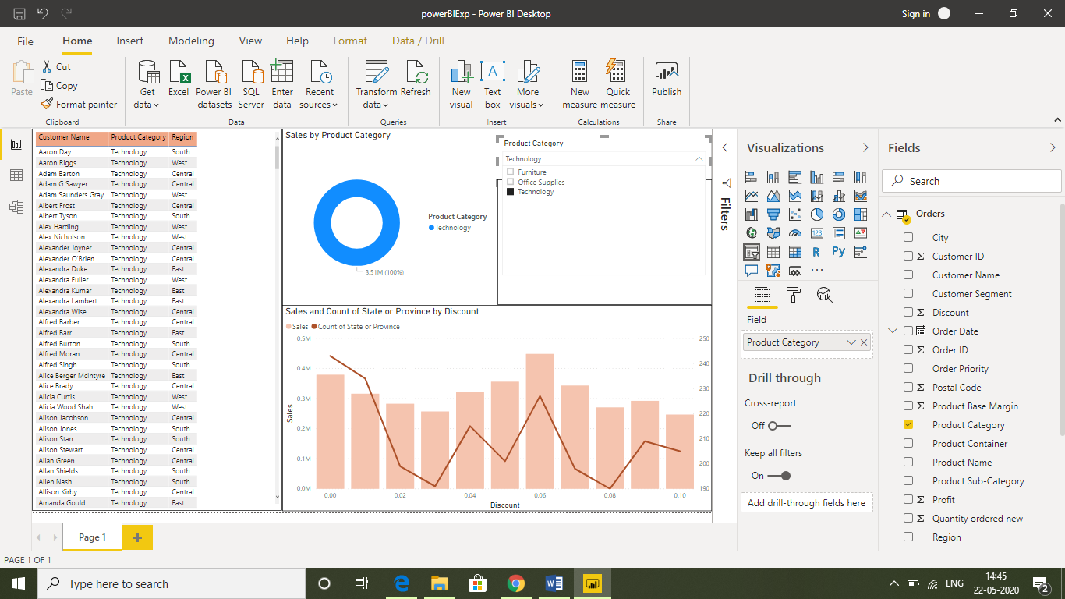

* **Create a Donut Chart showing sales in terms of Product category**

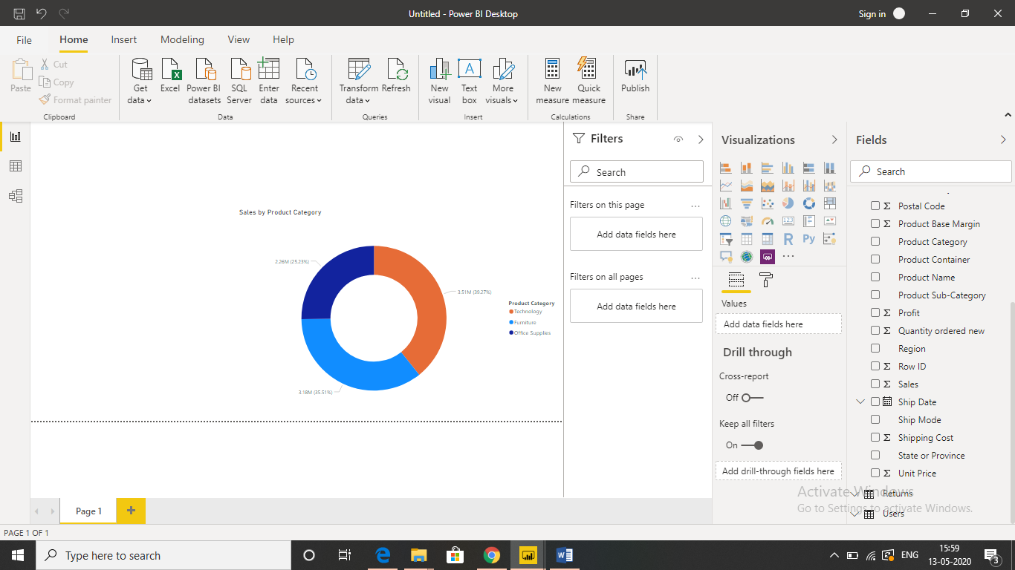

* **Create a Slicer and show the regions in dropdown. See how all the visuals mentioned above behaving when a particular region is selected.**

